Problem Statement

● **Explain Hive Architecture in Brief.**

● **Explain Hive Components in Brief.**

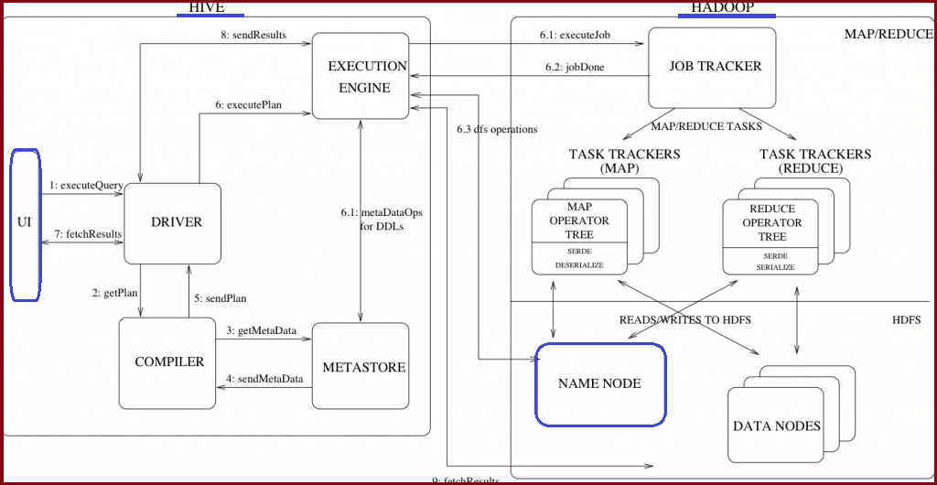

The above figure shows the architecture of hive.

* Hive is a data warehouse solution built on top of Hadoop by Facebook.
* It automatically uses HDFS for storage, but stores all the meta information about database and table in metadata DB locally to Hive.
* Hive is most suited for data warehouse applications, where relatively static data is analyzed, fast response times are not required, and when the data is not changing rapidly.

The different blocks in hive architecture are:-

**UI**

• The user interface for users to submit queries and other operations to the system. For example, command line interface and a web based GUI.

**Driver**

• The component which receives the queries.

• This component implements the notion of session handles and provides execute and fetch APIs modelled on JDBC/ODBC interfaces.

**Compiler**

• The component that parses the query, does semantic analysis on the different query blocks and query expressions and eventually generates an execution plan with the help of the table and partition metadata looked up from the metastore.

**Metastore**

• The component that stores all the structure information of the various tables and partitions in the warehouse including column and column type information, the serializers and deserializers necessary to read and write data and the corresponding HDFS files where the data is stored.

**Execution Engine**

• The component which executes the execution plan created by the compiler. The plan is a DAG of stages. The execution engine manages the dependencies between these different stages of the plan and executes these stages on the appropriate system components.

**Working:**

**Step 1** -The UI calls the execute interface to the Driver

**Step 2** -The Driver creates a session handle for the query and sends the query to the compiler to generate an execution plan

**Step 3&4** -The compiler needs the metadata so send a request for getMetaData and receives the sendMetaData request from MetaStore.

**Step 5** -This metadata is used to typecheck the expressions in the query tree as well as to prune partitions based on query predicates. The plan generated by the compiler is a DAG of stages with each stage being either a map/reduce job, a metadata operation or an operation on HDFS.

**Step 6**- The execution engine submits these stages to appropriate components. Once the output is generated, it is written to a temporary HDFS file though the serializer. For DML operations the final temporary file is moved to the table’s location

**Step 7, 8 & 9**-For queries, the contents of the temporary file are read by the execution engine directly from HDFS as part of the fetch call from the Driver

The various Hive components are:

**Metastore-**

The component that stores all the structure information of the various tables and partitions in the warehouse including column and column type information, the serializers and deserializers necessary to read and write data and the corresponding HDFS files where the data is stored.

**Driver-**

The component which receives the queries .

Manages lifecycle of a HiveQL statement as it moves through Hive.

It also maintains a session handle and session statistics.

**Query Compiler-**

The component that parses the query, does semantic analysis on the different query blocks and query expressions and eventually generates an execution plan with the help of the table and partition metadata looked up from the metastore.

Compiles HiveQL into a directed acryclic graph of MapReduce tasks.

**Execution Engine-**

The component which executes the execution plan created by the compiler. The plan is a DAG of stages. The execution engine manages the dependencies between these different stages of the plan and executes these stages on the appropriate system components.

Executes the tasks produced by the compiler in proper dependency order.

**Hive Server-**

Provides a thrift interface and a JDBC/ODBC server and a way of integrating Hive with other applications.

**Extensibility Interfaces**-

Is like the Command Line Interface (CLI), the web UI and JDBC/ODBC driver.It includes SerDe as well as the UDF(User Defined Function) and UDAF(User Defined Aggregate Function) interfaces that enable users to define their own custom functions.